1.3 Volumes by Revolution: Shell Method
In 1.2 we found that we could compute the volumes of solids or revolution using the washer and disk methods. However, some volume problems are difficult to hand using these methods.

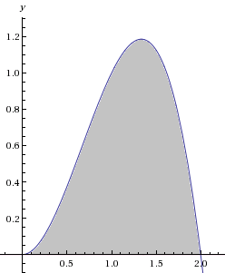
Motivation: Find the volume when the region enclosed by the curves and is rotated about the y-axis.
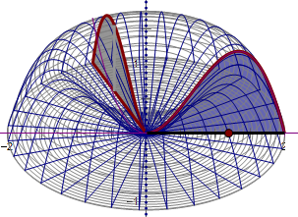

The following link helps to illustrate the Cylindrical Shell Method.
http://mathdemos.org/mathdemos/shellmethod/

Now, let’s see if we can generate a Riemann sum using cylindrical shells instead of disks. Consider the picture below:
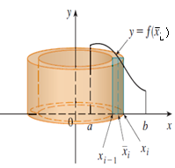

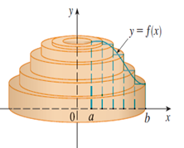

Cylindrical Shell Method

Volume of a Solid of Revolution (w/ a vertical axis of rotation)
If S is a solid that lies between whose volume can be computed using cylindrical shells, then the volume of S is given by
where r is the radius of any cylindrical shell and h is the height of any cylindrical shell. Both r and h are functions of x.

Volume of a Solid of Revolution (w/ a horizontal axis of rotation)
If S is a solid that lies between whose volume can be computed using cylindrical shells, then the volume of S is given by
where r is the radius of any cylindrical shell and h is the height of any cylindrical shell. Both r and h are functions of y.

Example 1: Find the volume when the region enclosed by the curves and is rotated about the y-axis.

Example 2: Suppose S is the solid obtained by revolving the region enclosed by and about the y-axis.

- Find the exact volume of S by using cylindrical shells.

- Find the exact volume of S by using washers/disks.

Note:
- The shell will always be parallel to the axis of rotation.
- Therefore if “washers/disks are dy”, then “shells are dx” (and vice-versa).

Example 3: Use cylindrical shells to find the volume when the region enclosed by the curves is rotated about the x-axis.

Example 4: Find the volume when the region enclosed by the curves and is rotated about the line .

